HOMEWORK 3

ANSWERS:

1 . C
2. regedit
3. There are Six hives on the Window Registery and they are :
- HKEY_CLASSES_ROOT
- HKEY_CURRENT_USER
- HKEY_LOCAL_MACHINE
- HKEY_USERS
- HKEY_CURRENT_CONFIG
- HKEY_DYN_DATA
4.
Step by Step Screenshot of the My Computer\HKEY_CURRENT_USER\Software\Microsoft\Windows\CurrentVersion\Run

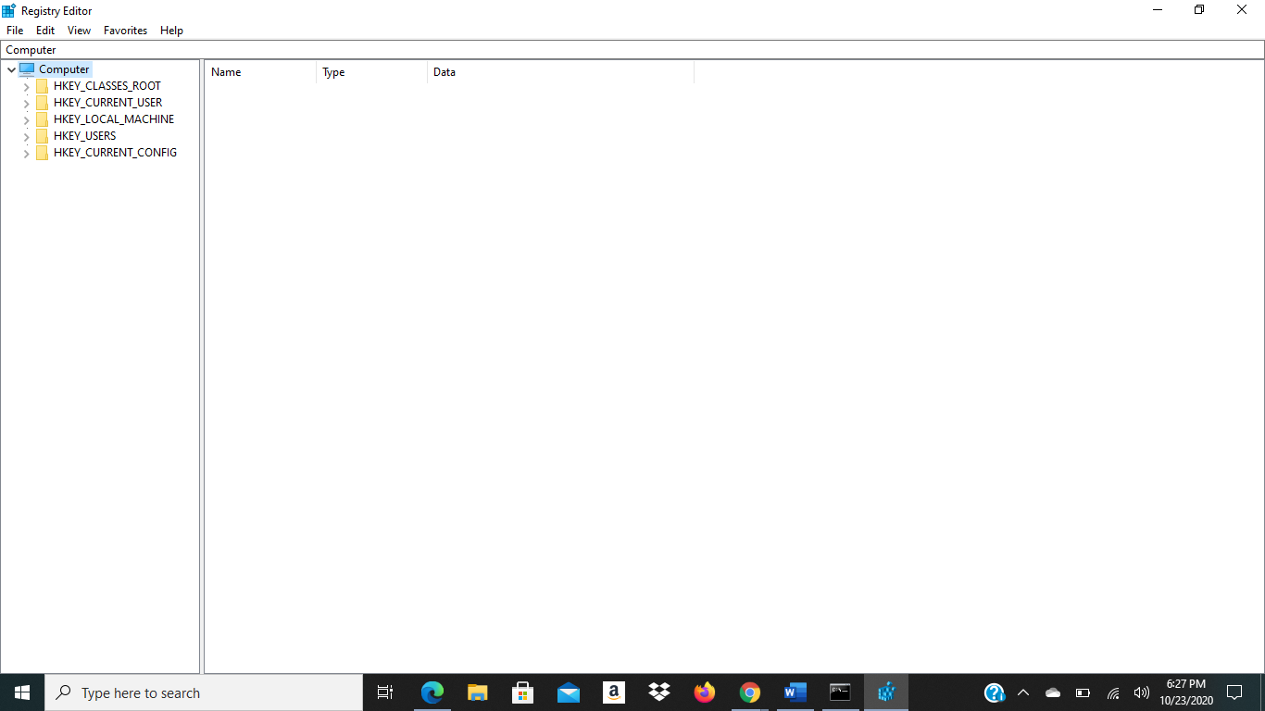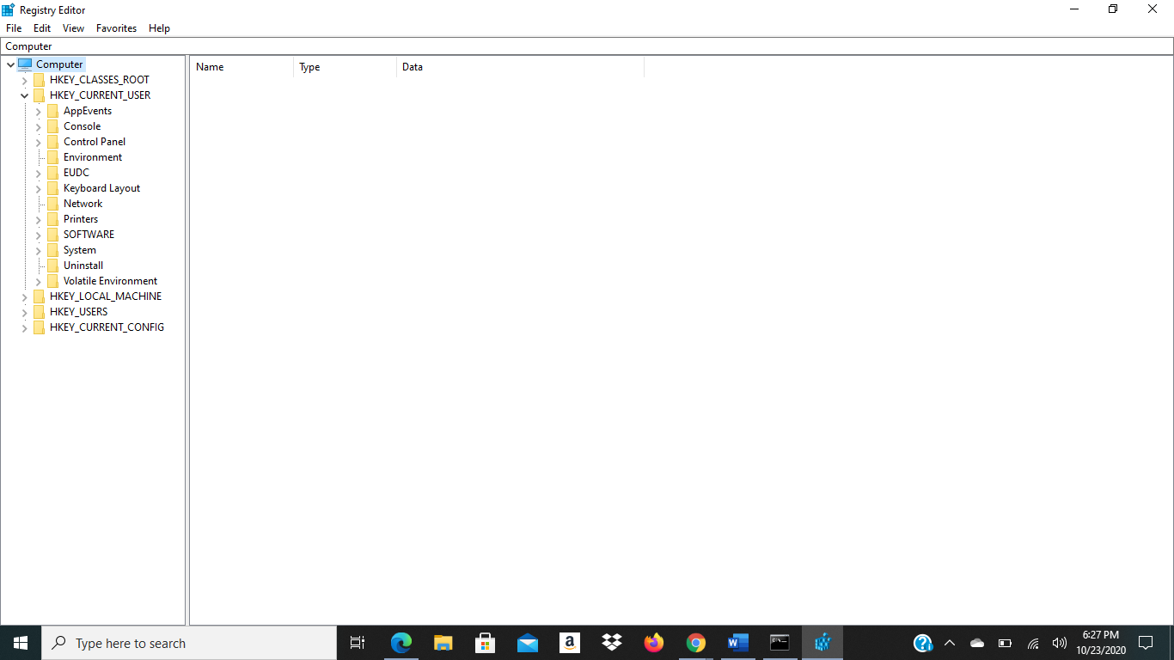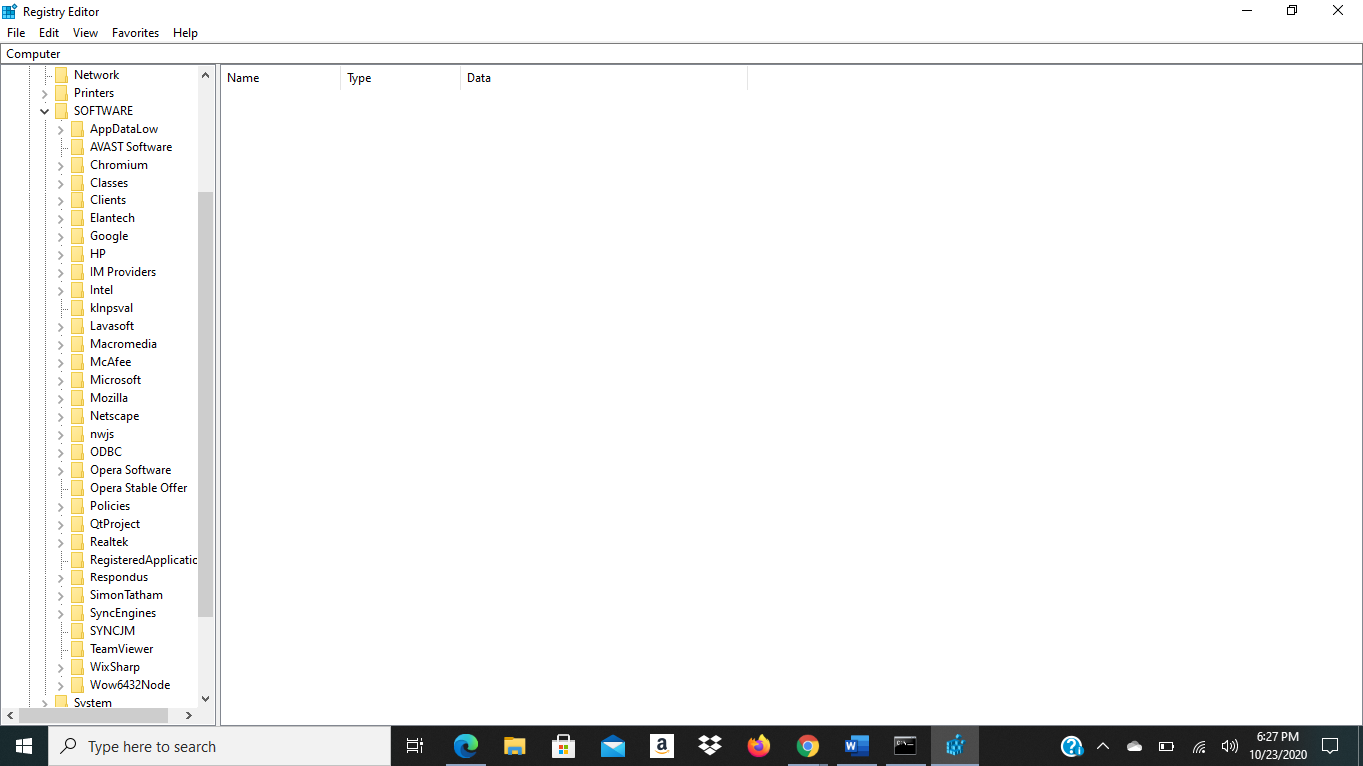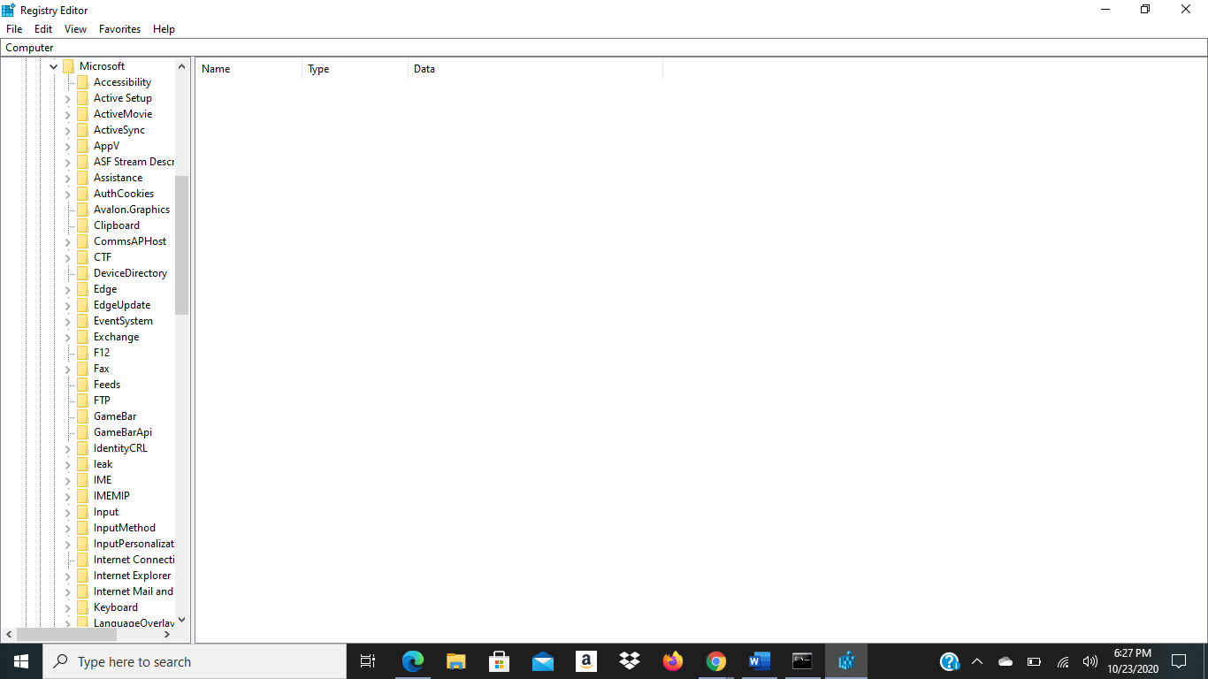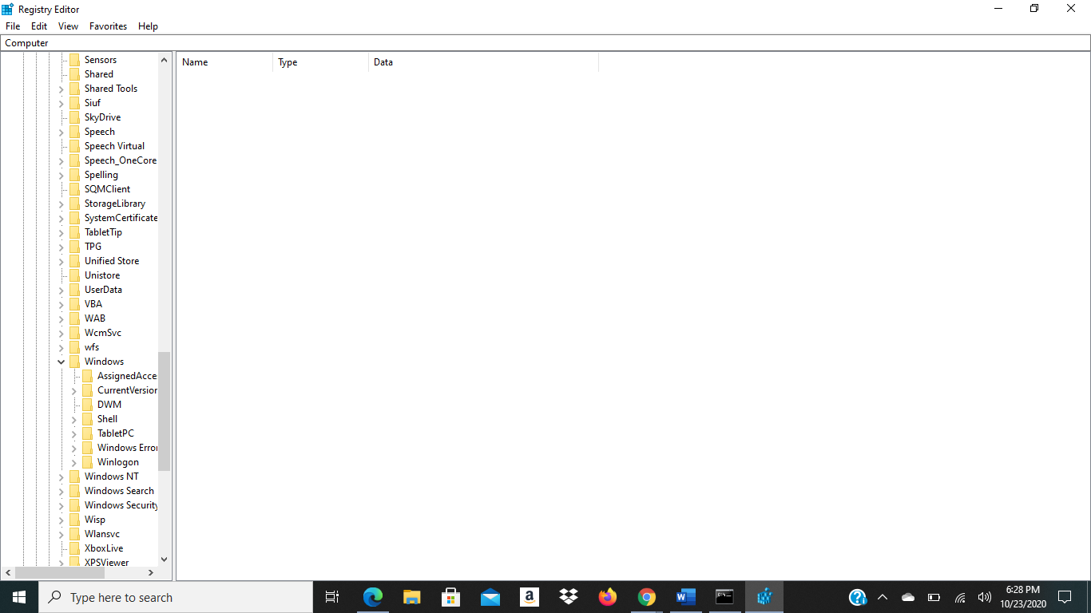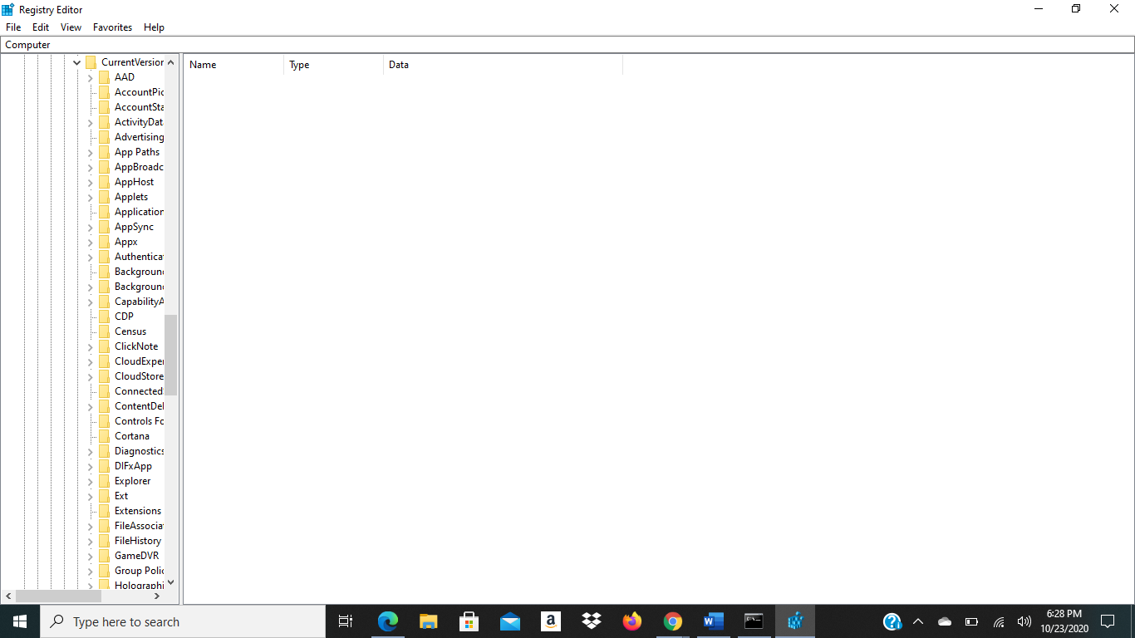
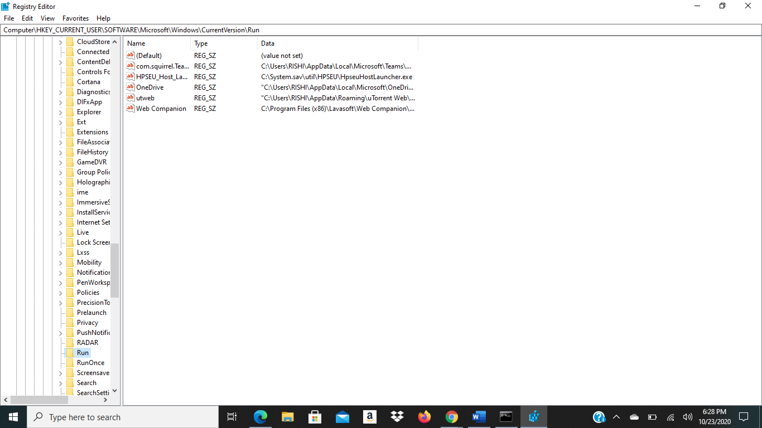

The 6 File are shown at the end In the Run Folder.

Functionality :

The function of the key is to make programs appear at the startup automatically.

4.b
You need to create a new string named notepad in the key. The value would be the following path: c:/windows/system32/notepad.exe

5. RegOpenKeyEx, RegSetValueEx, RegCreateKeyEx, etc

6. D
7. D
8. A
9. B
10. B
11. B
12. A
13. C

14.
The address 0xc8821f21 is the suspicious address. Whenever an address above 0xc8800000 is referenced in the system call table, it indicates that the kernel has been compromised.
15. WinMain
16. HINSTANCE hlnstance, HINSTACE hPrevlnstance, LPSTR IpCmdLine, int nCmdShow
17. B
18. A and D
19.a
Installs an application defined hook procedure into a hook chain.
19.b
Contains information about low-level keyboard input event
19.c
Passes the hook information to the next hook procedure in the current hook chain
20. ShowWindow(…, SW_HIDE);
21. 12 AND 12
22. I have completed the program in the file Question 22 Folder.

